CPE301 – SPRING 2019

Design Assignment 3B

Student Name: Carlos D Zuniga

Student #: 2000783713

Student Email: zunigc2@unlv.nevada.edu

Primary Github address: https://github.com/cdaniel64/blassen/

Directory: DA3/DA3B

1. **COMPONENTS LIST AND CONNECTION BLOCK DIAGRAM w/ PINS**

List of Components used

ATMEGA328P, HITLEGO Shield, and HITLEGO FTDR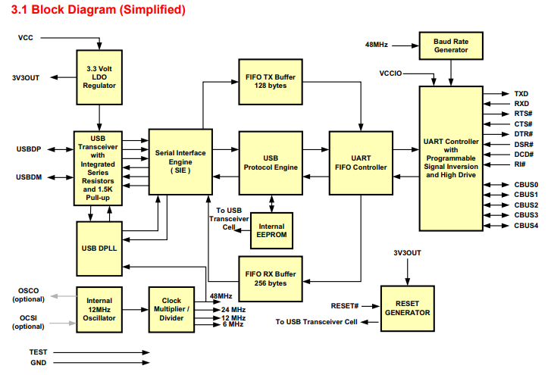

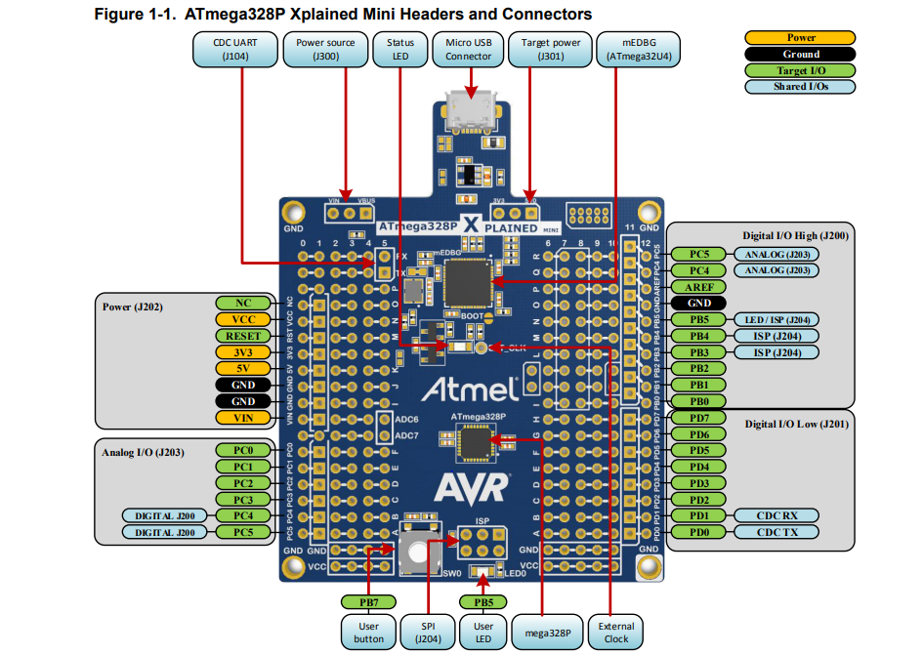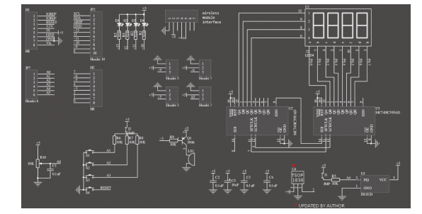

1. **INITIAL/MODIFIED/DEVELOPED CODE OF TASK 1**

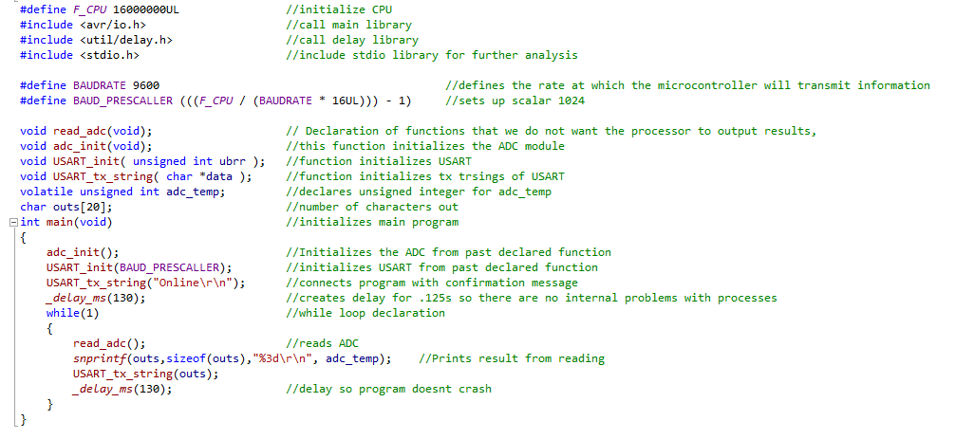

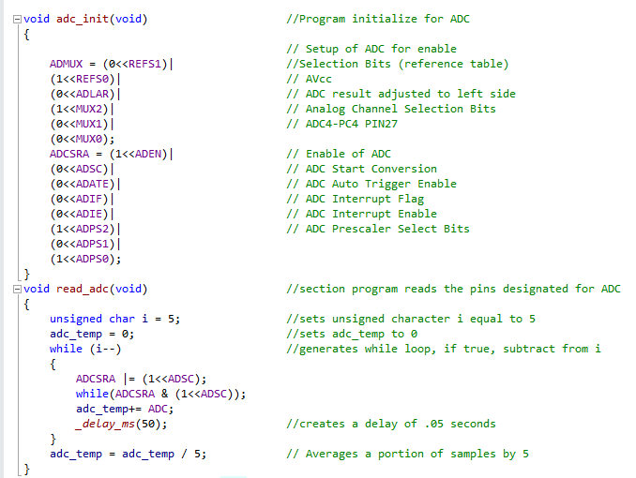

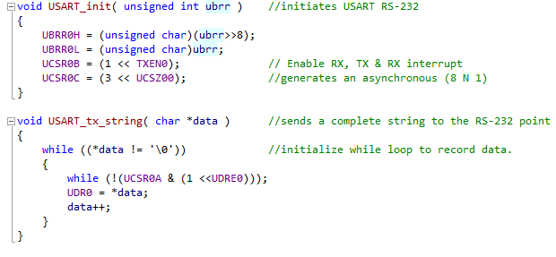

1. **SCHEMATICS**

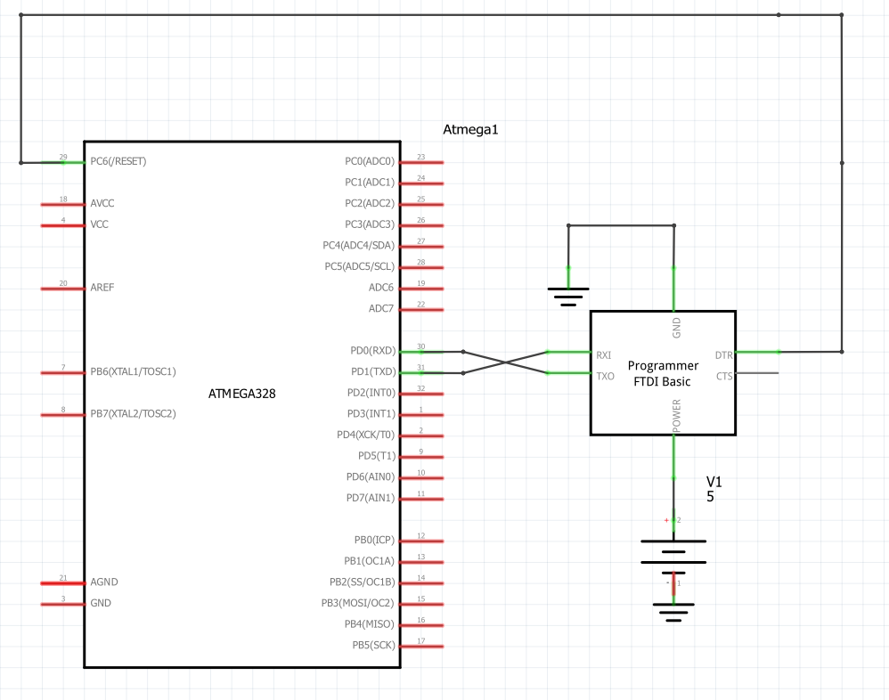

1. **SCREENSHOTS OF EACH TASK OUTPUT (ATMEL STUDIO OUTPUT)**

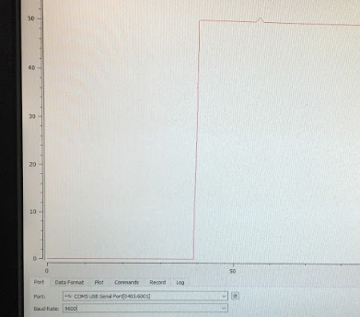

1. **SCREENSHOT OF EACH DEMO (BOARD SETUP)**

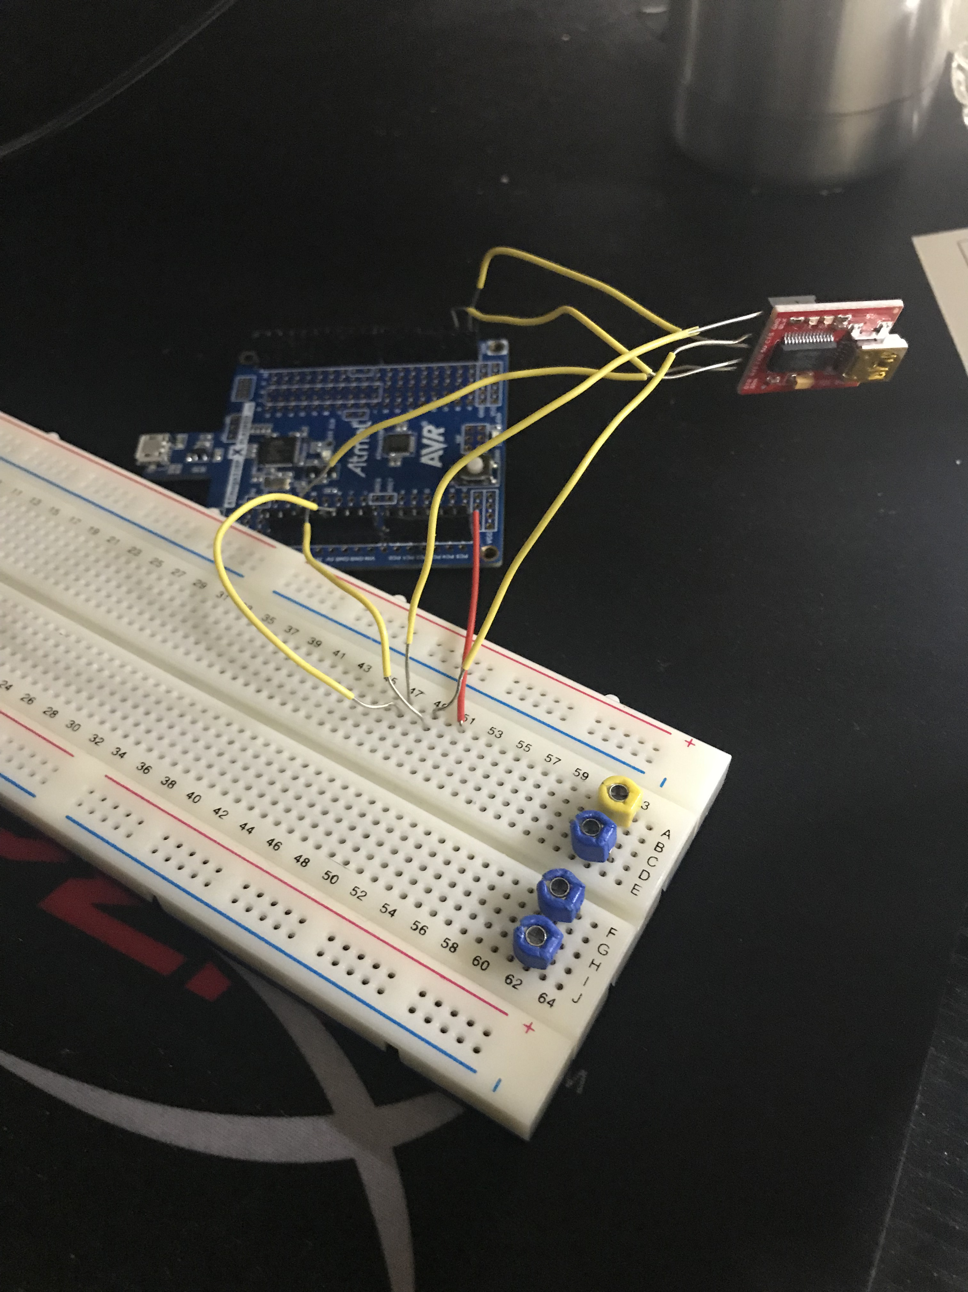

1. **VIDEO LINKS OF EACH DEMO**

<https://www.youtube.com/watch?v=Kj_p-_9DEYM>

1. **GITHUB LINK OF THIS DA**
2. <https://github.com/cdaniel64/blassen>

**Student Academic Misconduct Policy**

<http://studentconduct.unlv.edu/misconduct/policy.html>

“This assignment submission is my own, original work”.